Called to Just Peace
Co-Pastor Susanne Guenther Loewen
NPMC In Person and Livestreamed Worship
August 30, 2020

Scripture: Exodus 3:1-15, Romans 12:9-21
Hymn: HWB 407 – We Are People of God’s Peace

One of our highlights of homeschooling last Spring was exploring ancient Egypt. After a bumpy start, we discovered that our 7-year-old is interested in history, so we ran with that. Our ancient Egypt theme included learning about pharaohs and deciphering hieroglyphics – and since I couldn’t help but throw in some Bible content (teach what you know, right?), we ended with the story of Moses and the Exodus from Egypt. To many of us it’s a very familiar story, perhaps even bringing to mind the famous Ten Commandments movie from the 1950s! But my son saw it with fresh eyes, and found it amazing – he would definitely recommend The Prince of Egypt movie about Moses that we watched together.
Our Scripture for today picks up where Don Klaassen’s sermon left off two weeks ago in the story of Moses. It begins with the famous story of the burning bush. This is Moses’s call story, his commissioning by God to be the liberator of the Israelite people from their dire situation of oppression and suffering. But it begins when he has run away from his life in Egypt and is now a shepherd in Midian, out in the wilderness. He thinks he has left all things Egypt behind and had a fresh start. But God has other, more challenging plans for him.
As we well know, Moses comes to a bush that is burning but not burning up, and when he goes to have a closer look, God speaks to him by name from the flames: “Moses, Moses!” “Come no closer! Remove the sandals from your feet, for the place on which you are standing is holy ground” (Exodus 3:4-5). Now God appearing in fire shouldn’t come as a surprise to us – it’s a recurring image for God throughout the Bible, from the pillar of fire by night which will later go with the Israelites into the wilderness to the tongues of fire that appear on the disciples’ heads at Pentecost. And in all of these scenarios, God issues a challenging call to step out into the unknown.
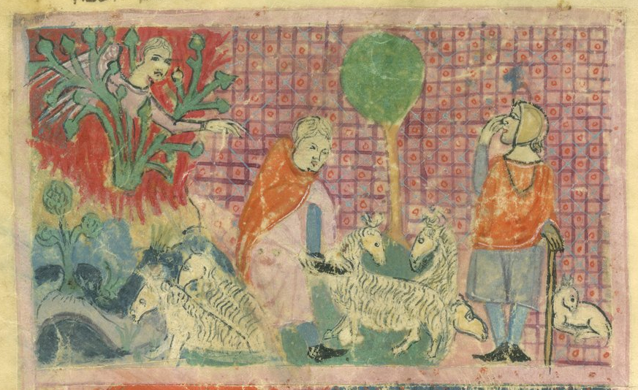
Moses Before the Burning Bush (from the Haggadah for Passover) – Wikimedia Commons
Rereading the burning bush story, I was struck with how God identifies Godself: God is the God of Moses’ ancestors, yes, but also, importantly, the God who has heard the cries of the oppressed Israelites. God says to Moses, “I have observed the misery of my people who are in Egypt; I have heard their cry on account of their taskmasters. Indeed, I know their sufferings, and I have come down to deliver them from the Egyptians, and to bring them up out of that land to a good and broad land, a land flowing with milk and honey, to the country of the Canaanites, the Hittites, the Amorites, the Perizzites, the Hivites, and the Jebusites. The cry of the Israelites has now come to me; I have also seen how the Egyptians oppress them. So come, I will send you to Pharaoh to bring my people, the Israelites, out of Egypt" (3:7-10). Notice how God repeats four times that God has heard their cries and knows how they are oppressed and suffering? And so God, through Moses, is taking concrete action to deliver them and liberate them from this suffering.
But Moses is skeptical – and why shouldn’t he be? He’s being sent on a very dangerous mission to defy a Pharaoh – a king who was seen as part-divine in Egyptian culture – and to ask for an entire group of slaves to be set free! Moses asks God for a bit more information – for a more specific name that he can give as to who has called him to this task. “I am who I am” is how God identifies Godself – a phrase which in Hebrew can also mean “I will be who I will be.” Reading into this a bit, we might affirm that God is the God who is and will be – the God of Life and the God of the future – the God whose midwives defy orders to save babies in Exodus 1 – the God who desires for the enslaved Israelites “a future with hope” as says in Jeremiah 29. This is the God who is sending Moses to liberate the people of Israel.
We know the rest of the story – the plagues, the Passover, the crossing of the Red Sea on dry land as the Exodus finally happens. This is a key Bible story – one that some say is actually more important and more identity-defining than anything in Genesis. Theologian Dorothee Soelle makes a case for this story being more important than the creation narratives. “In the beginning was liberation,” she writes. And she continues, “Biblical faith originated from a historical event of liberation, not from belief in creation. For the people of Israel, the Exodus from Egyptian slavery was … a ‘root experience’ … [which] continues to have the utmost relevance for later generations.” So for the Israelites, their first major identity-defining moment was not creation, but their liberation from slavery in Egypt. That was the people they became: the people who had been freed from slavery, and who worshipped a God of liberation. This really is a radical story, the ultimate underdog story, which is somewhat lost on us.
But it certainly was not lost on the white plantation owners during the era of African-American enslavement. In her book, Fire By Night, Mennonite pastor Melissa Florer-Bixler mentions that during the time of chattel slavery, white plantation owners gave enslaved Black people abridged versions of the Bible, such as one called, Selections of the Holy Bible for Negro Slaves. Guess which story was not included among the selections? That’s right, the Exodus story. Florer-Bixler explains why: “White, slave-holding Christian communities understood the Bible to contain radical and dangerous notions about freedom, a subversive Old Testament narrative of a subjugated people who fled captivity in Egypt and were led by God into a promised land.” This is what Johann Baptist Metz called a “dangerous memory” – a biblical story with clear socio-political implications that disrupted a system of oppression by affirming that God is a God of liberation, not slavery. Knowing that God liberates the oppressed has the power to change everything – and indeed, the story of the Exodus became one of the most important stories for Black liberation theologians when that branch of theology developed in the 20th century.
Well, if Soelle is right, and “in the beginning was liberation,” the question remains: what are God’s people liberated for? I remember this question in one of my theology classes on salvation and redemption. Throughout church history, Christians have tended to focus on the question of “what are we saved from?” And answers range from sin to death to broken relationships to slavery and oppression. But the second question is, “what are we saved or liberated for?” And that’s where our Mennonite emphasis on discipleship or following in the Way of Jesus comes in, which is picked up in Paul’s letter to the early Christians in Rome.
Now I came across this passage this summer when I was preparing the curriculum for the kids’ Peace Club we’re starting this Fall for school-age children. It was in a book called Kids Can Make Peace, as a guiding passage for a club of this kind, focused on learning about peace. My first thought was, that passage is way too advanced for kids that age! A lot of adults aren’t into reading Paul’s theological letters, never mind kids ages 7-11. But when I looked at it more closely, it seemed more accessible than I thought. Here we have, in quite concrete and practical terms, what it means to be people of peace. This is what people of peace do and don’t do, according to Paul: they practice genuine and mutual love, they serve one another no matter their social standing, they rejoice in hope and prayer with one another’s joys and sorrows, they are hospitable even to strangers, and so on. And Paul has a few things to say about how they respond to evil scattered throughout – they “hate what is evil” and “hold fast to what is good”; they “bless and do not curse” their enemies; they “do not repay anyone evil for evil”; they do not act vengefully. “If it is possible, so far as it depends on you, live peaceably with all,” Paul says. “Do not be overcome by evil, but overcome evil with good.” Now we don’t use the word evil much anymore, but in the New Testament Greek, this word means “wickedness” or “inner malice” or “a morally-rotten character.” So this kind of evil is to be “hated” and overcome with good – the kind of evil that comes with, say, it being legal to own and enslave another human being or do violence to them with no repercussions because of the colour of their skin. As people of God’s peace, Paul calls us to hate this kind of evil – strong language! – and to hold fast to what is good, to overcome the evil with good. Here Paul tells us that peace will overcome evil and violence. Peace is a powerful thing.

So what do we get when we hold our two passages together? We have in the Exodus a powerful story of deliverance and liberation, and a passage detailing interpersonal peace within and beyond a faith community. We have the justice of slaves being freed and the peace practices that make for a genuine and healthy community. And these go together. Psalm 85:10 puts it in terms of a marriage: “Steadfast love and faithfulness will meet; righteousness and peace will kiss each other.” This is that all-encompassing sense of peace as shalom – equity, well-being, and right relationship. In more contemporary terms, peace scholars and practitioners speak of “just peace” – that is, peace that goes hand in hand with justice, that pays attention to matters of justice. We cannot have peace when we just smooth over the underlying inequities and injustices – that is not true peace. True peace requires liberation and justice – and with that freedom, we can become people of God’s peace. We are liberated for peace; that liberation empowers us to make peace.
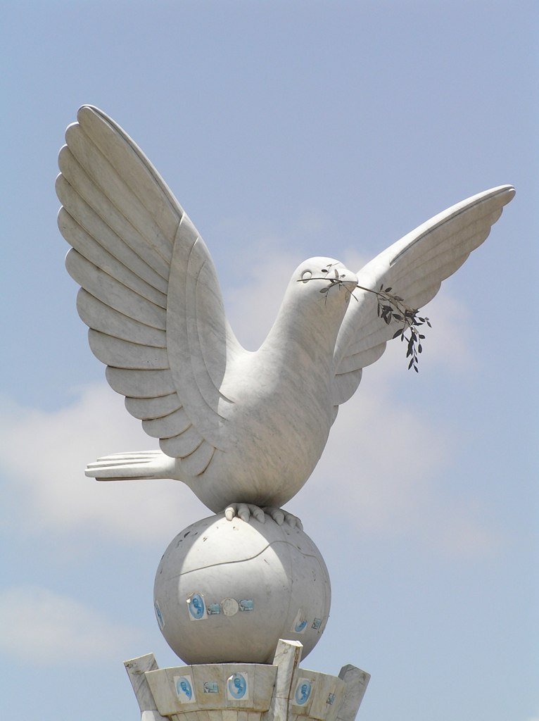
I think that’s a gift of our Mennonite tradition’s emphasis on discipleship in Jesus’ Way of Peace and Justice that I’d like to pass on to the children of this congregation as we start up Peace Club. They can make peace, as kids – they can be “peace heroes” as one of our lessons puts it. That’s the encouraging and empowering message
Peace Dove in Lomé, Togo – photo by Jeff Attaway (Wikimedia Commons)
that our faith has for us. Another world is possible, and God has invited us to join in that project of building justice and peace. In the words of Drew Hart, “God’s delivering presence is a force that we can join.” May we have the courage to live into that calling, together. AMEN

Dorothee Soelle, To Work and To Love: A Theology of Creation, with Shirley Cloyes (Philadelphia: Fortress Press, 1984), 7.
Melissa Florer-Bixler, Fire By Night: Finding God in the Pages of the Old Testament (Harrisonburg, VA: Herald Press, 2019), 26-27.
Strong’s Biblical Concordance, https://biblehub.com/greek/2556.htm
Drew G.I. Hart, Who Will Be a Witness? Igniting Activism for God’s Justice, Love, and Deliverance (Harrisonburg, VA: Herald Press, 2020).

