Comfort and Rest
Co-Pastor Susanne Guenther Loewen
NPMC - July 5, 2020

Scripture: Genesis 24:42-49, 58-67; Song of Solomon 2:8-13; Matthew 11:16-19, 25-30

Hymn: Comfort, Comfort O My People - HWB #176

A couple of weeks ago, our NPMC Board had its last official meeting of the year. Usually, we’d have a potluck BBQ at someone’s house, but this year, we settled for a physically-distanced, bring-your-own snacks tailgate gathering in the church parking lot. After months of meeting only on Zoom video calls, though, it felt like a real comfort and luxury to meet in person, to see each other face to face! As we went around the circle and shared what we had learned during the last few months, I realized I have learned a lot about comfort and rest – that is, about the importance of the balance between work and rest, about the grace for oneself which is needed to really rest. It’s true what they say in the safety demonstration on airplanes – one needs to put on one’s own oxygen mask before helping someone else put on theirs. Or, as I’ve heard elsewhere, you can’t pour from an empty cup. Especially in times of profound change, like we’ve seen in the past several months, proper rest doesn’t get in the way of work – it makes the work possible and sustainable.
I suspect we in the Mennonite church don’t hear a lot of sermons about comfort and rest. Well, maybe at funerals. But otherwise, Mennonite spirituality is very much oriented toward “doing” – we are a tradition that values faith as discipleship and peacemaking and service. There is nothing wrong with this, of course – it’s something I love about the Mennonite church, and I think it’s a gift we contribute to the wider church as well. But I wonder if we haven’t underemphasized the other side of the balance: the importance of comfort and rest, especially as the Protestant/Mennonite work ethic has blended with today’s culture of busyness and “productivity” at all costs. For some of us, the pandemic has brought a welcome time of slowing down and re-evaluating the formerly hectic pace of our lives. For others, this time has been busier than before, and they long for a time of rest.
Looking to the Bible, we find that comfort and rest come up repeatedly. This isn’t some obscure, hard-to-find theme – in fact, it’s there in the very first chapter of Genesis when God the Creator rests on the seventh day, marking the very first sabbath. Rest is woven into the balance and cycles of creation from the very beginning – day and night, the changing seasons, the stages of our lives, the generations which follow one another, and yes, the weekly Sabbath rest. So in this sermon, I want to look at three snapshots of comfort and rest provided by the lectionary passages for today.
Creation from The St. John’s Bible

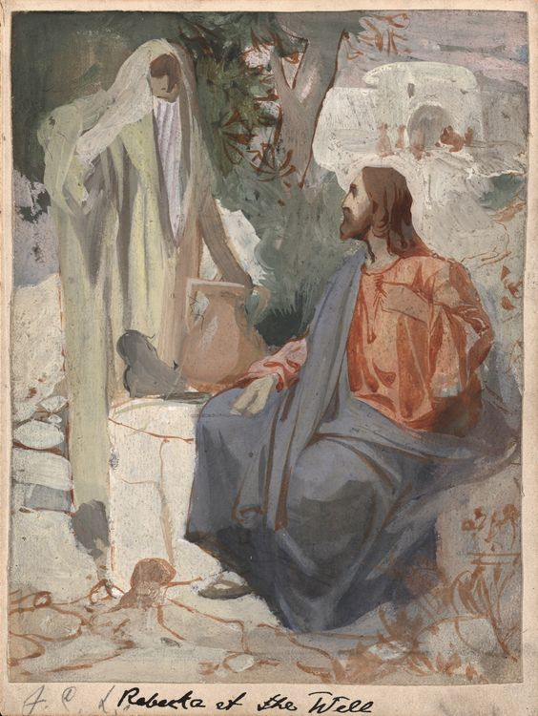
The first comes from Genesis 24, the story of how Isaac and Rebekah met and married. Now given the strangeness of the arranged, patriarchal, dowry-based marriage customs reflected in this story, we might not think at first glance that this story has anything theological to teach us. Isn’t it simply a weird, Bible-era romance meant to show the lineage of Abraham and Sarah? Well, there are a few interesting details in the story that are worth noticing. So we have Abraham sending his servant Eliezer to find a woman for his son Isaac to marry. But Eliezer has an interesting way of determining which woman to choose for Isaac. Just before our passage, Eliezer goes to a well, knowing that this is where young women go to collect water for their households. There, as he retells at the beginning of our passage, he prays to find a woman who will share water with him and offer to water his camels as well (Gen. 24:11-14; 42-44). While this may seem like a strange way of getting to know someone, it was actually quite an important aspect of life in that time and place. As a traveller in a dry, dusty, desert-like land, Eliezer (and his camels) relied very much on the hospitality of strangers; that’s why hospitality was such an important aspect of Middle Eastern faith and culture. When Rebekah offers him water and offers to water his camels on top of that, he knows that she is essentially a good person – she is someone who lives out the customs of welcoming the stranger, of offering generous hospitality to those who need it. She is a woman of good character, a woman of faith and compassion. This is, in part, why Eliezer chooses her and considers her worthy to marry Isaac. And once Rebekah has agreed to go and to marry Isaac, the story ends with noting that there was love between Isaac and Rebekah, and that Isaac found comfort in his relationship with Rebekah after the death of his mother (v. 67). So a time of grief in Isaac’s life was transformed to comfort and joy as Rebekah became his new family. This relationship changed his life for the better, and we can imagine that was because of who Rebekah was. That’s the thing about our closest relationships – they can bring out the best in us, which is a beautiful thing. And they can provide a place of sanctuary – of rest and belonging, of being our true selves, known and loved.
By J.C. Leyendecker, 1893
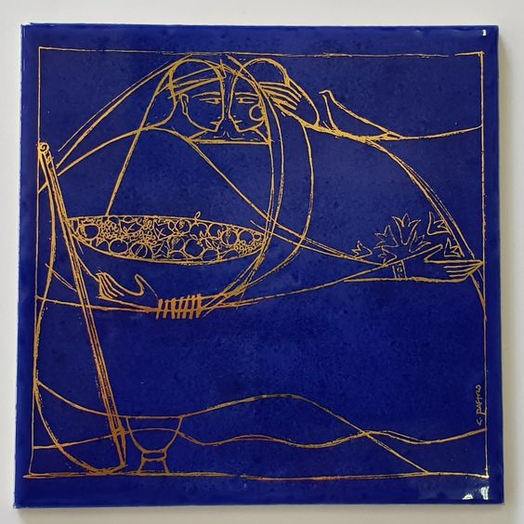
Nowhere in the Bible is this idea clearer than in the Song of Solomon, also called the Song of Songs, an interesting – and at times downright racy! – book about two lovers that has been interpreted in all kinds of ways. In the Jewish tradition, it’s said to be a metaphorical song about the love between God and Israel; in later Christian interpretation, it was said to be about the love between Christ and the Church. But however you look at it, it’s a book about the sacredness of our closest relationships. Alice Connor puts it this way: “The Song of Songs holds up a mirror and says,… ‘Don’t you see your own relationship here? And maybe your love of God here, too?’ … You know this feeling. Not just the heart palpitations of a crush, but the deep connectedness to someone you truly love and who loves you back. For some that might be a romantic or married partner; for others, it might be a deep soulfriend; for others, it could be the relationship you have with a parent or sibling. These are beautiful experiences, and they require a certain vulnerability on our end. To the extent that we allow our real, inner selves to be seen, we are loved all the more. In the same way, we have to be able to be vulnerable to God.”
Cantico dos Canticos by Claudio Pastro

Cântico dos Cânticos Cláudio Pastro

Cântico dos Cânticos Cláudio Pastro

In our passage for today from the Song of Solomon, the profound love of the couple for one another is mirrored in the joy of spring as it unfolds in the natural world beyond their window. Starting at verse 10, we read, “My beloved speaks and says to me: ‘Arise, my love, my fair one, and come away; for now the winter is past, the rain is over and gone. The flowers appear on the earth; the time of singing has come, and the voice of the turtledove is heard in our land. The fig tree puts forth its figs, and the vines are in blossom; they give forth fragrance. Arise, my love, my fair one, and come away’” (Song of Solomon 2:10-13). The two of them have been through the difficulties of winter together, and now Spring brings with it beauty and joy – they can now rest in their love as the earth flowers around them. It’s an idyllic image.
When I read this passage, I couldn’t help but think of the winter we’ve all been through, and the relief that spring and summer have brought. For many of us, the warmer weather has brought with it the opportunity to see friends and loved ones again, since physically-distanced gatherings outside are even safer than meeting indoors. For some of us, it had been a really long and painful wait, and reconnecting with loved ones in person has been such a comfort and a joy! Like the couple in the Song of Solomon, spring this year has brought with it a reprieve from the struggles of wintertime, a season of rest as we loosen some of the strict requirements of isolation and shut-down that we were called to earlier this year.
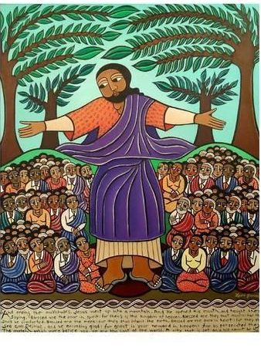
Here at church, our reopening committee has likewise started working on the possibilities surrounding carefully and thoughtfully reopening our building and meeting safely as a community again. This will look and feel different than regular church, especially because not everyone feels comfortable or is able to meet in person due to other health concerns. I’ve realized over the past few months that many of us experience church as a place of sanctuary, a place of safety and belonging, rest and welcome. The question we have been asking ourselves since March is, how can we experience that safety and belonging, rest and welcome, across the distance, in those times when we cannot gather in person? It’s been a challenging question, but from what we hear, whether we are gathering in person or listening online through our audio worship services, we are experiencing Jesus among us and between us these days.
Sermon on the Mount, 2010 – by Laura James
This is what Jesus promises in our passage from Matthew for today – one of my favourite of Jesus’ teachings. He starts with pointing out the differences between his ministry and that of John the Baptist. John emphasized radical self-denial and fasting, while Jesus makes a point of eating and drinking with people from all walks of life in his ministry of table fellowship and connection and celebration. Coming back to the Mennonite ethos of all work and no rest, we see that Jesus actually made a lot of time to simply spend with other people - his ministry was about those moments of rest, hospitality, joy, and belonging in relationship with other people; it was about making that possible, above all, for those who were excluded from that, who were longing for that. So he concludes with an invitation to rest in his presence: “Come to me, all you that are weary and are carrying heavy burdens, and I will give you rest. Take my yoke upon you, and learn from me; for I am gentle and humble in heart, and you will find rest for your souls. For my yoke is easy, and my burden is light” (Matt. 11:28-30). Whether we’re together or apart, then, Jesus provides sanctuary. Jesus provides a welcoming place of belonging and rest, whether or not we’re able to gather in this church building, in this physical sanctuary. Jesus provides us with the inner peace that comforts us and strengthens us for the journey, wherever it leads. It’s a powerful reminder, in the words of Jan Richardson, that “Beloved is where we begin.” And that makes all the difference. AMEN
Laura James – Sermon on the Mount, 2010

Alice Connor, Fierce: Women of the Bible and their Stories of Violence, Mercy, Bravery, Wisdom, Sex, and Salvation (Minneapolis: Fortress Press, 2017), 92-93.
Her full poem can be found at: Jan Richardson, Circle of Grace: A Book of Blessings for the Seasons (Orlando FL: Wanton Gospeller Press, 2015), 96-98. See also: https://paintedprayerbook.com/2016/02/11/lent-1-beloved-is-where-we-begin/

