Pentecost: Spirit as Breath of Life
Co-Pastor Susanne Guenther Loewen
NPMC – May 31, 2020

Scripture: Acts 2:1-4, 22-28, Job 33:4, John 20:19-22
Hymn: StJ 10 – Spirit, Working in Creation

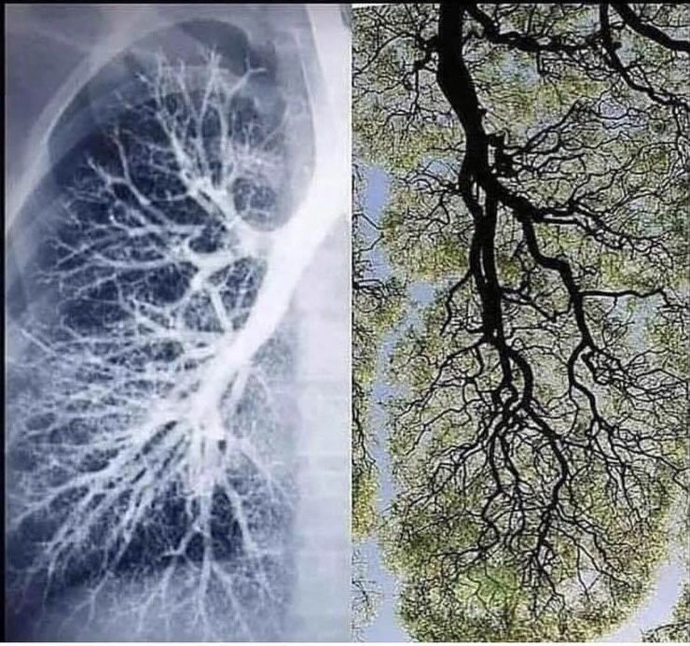
I came across a striking picture as I was preparing for this sermon on the Holy Spirit as the Breath of Life. It shows two images side by side: one is of the branch-like air passages inside a human lung, and the other shows the branches of a tree against the sky. The shapes are undeniably parallel, clear echoes of each other’s structure: the great majestic branches of trees that provide the oxygen for the small, unseen branches inside our lungs – and we, in turn, release the carbon dioxide needed by the trees, and so on. This is a reminder of what we sometimes forget: that we are dependent on other living things – especially trees – for the air we breathe, which is what keeps us alive. This is why forests are called the lungs of the planet. We are intimately interconnected in the carbon cycle with the rest of God’s Creation, in the many branches of the web of life.
Today is Pentecost, that Sunday when we focus on the most mysterious of the three members of the Trinity: the Holy Spirit. Now we often think of the Spirit as a Dove or as Fire, as in the Pentecost story from the book of Acts. But in keeping with our Garden theme, I wanted to look today at the Holy Spirit as the Breath of Life – the Life-Giving Spirit which infuses all of Creation, creating, sustaining, connecting, and recreating the rhythms of life on our planet. This name for the Spirit brings home for us that God is as close to us as our every breath. Or, as pastor Nadia Bolz-Weber half-jokingly says, “We are dirt and the breath of God.”
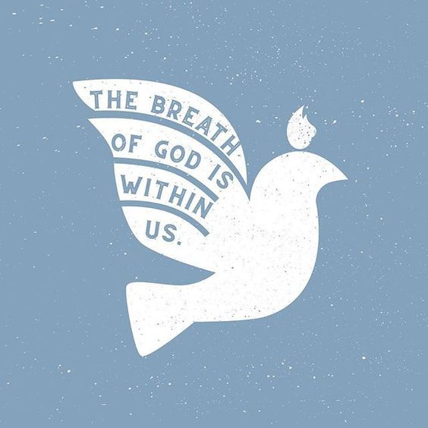
The Bible talks about this from the very beginning, though some of it is lost in translation for us. You may remember that the word for breath in both Hebrew (ruach) and Greek (pneuma) has multiple layers of meaning, so that it means something like wind-breath-spirit, all at once. So when a “wind from God” hovers over the waters at the beginning of Genesis, ancient listeners would have heard it as a divine Wind-Breath-Spirit hovering over the void before creation. This same Spirit will speak creation into being with its breath in the beautiful Creation poem of Genesis 1. This same Divine Wind-Breath will breathe the breath of life into the first human beings in the next chapter of Genesis. And in Job, as in elsewhere in the Hebrew Bible, we read that “The spirit of God has made me, and the breath of the Almighty gives me life” (Job 33:4). So we see that this theme of the ruach Elohim as it’s called in Hebrew – the Wind-Breath of God, the divine Breath of Life that God has breathed into us – is a key theme in the Hebrew Bible. And it’s an amazing thing to remember: God is as close to us as the very breath in our lungs. There is even a Jewish tradition of interpreting the name of God – Yahweh – not as a word, but “literally the sound of breath itself”: “Inhale, yah. Exhale, weh. Inhale, yah. Exhale, weh.” So Yahweh is another form of calling God the divine Breath of Life.
Lauren Winter

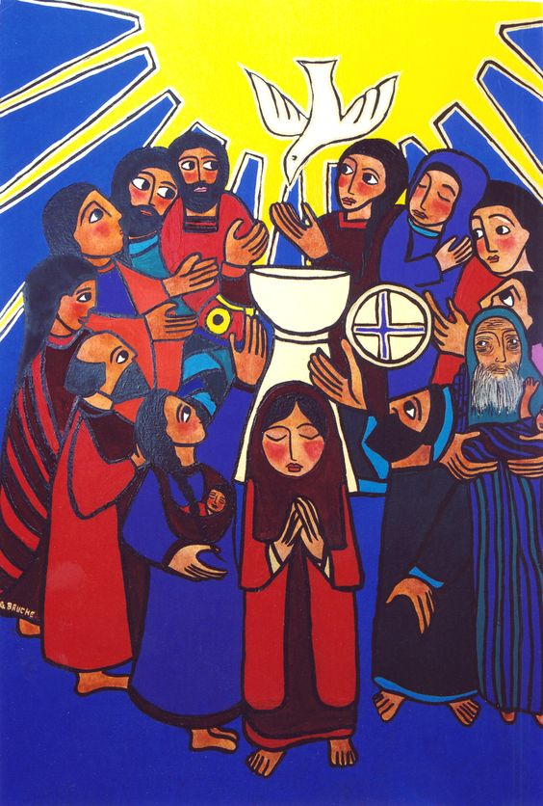
So when we come to the more familiar story of Pentecost in the New Testament, all of these other examples of the Wind-Breath-Spirit of God should be swirling around in our minds. In Acts 2:1-4, the male and female disciples of Jesus receive the Holy Spirit “when they were altogether in one place” – when they are, we might notice with particular attention these days, behind closed doors in a house – not at the Temple or in any special sanctuary or worship space.
Gisele Bauche - The Coming the Holy Spirit

There, in that ordinary house, they receive the Holy Spirit in multiple ways: first there is “a sound like the rush of a violent wind” – there’s that Wind-Breath image of the Spirit again; there is the sign of “tongues of fire” that “rested on each of them” – likely a nod to Moses’ burning bush; and there is the ability to speak in many different languages, which will serve them well as they proceed to share the story of Jesus with all the different peoples of Jerusalem in all of their diverse languages – a sign of God’s gift of relationship-in-diversity.
As I was pondering these three signs of the Spirit, it occurred to me that all of them are actually related to breath: the gust of wind-breath, the flames which cannot burn without a breath of air, the languages, which cannot be spoken aloud without breath. Here we have the divine Breath of Life manifest in multiple ways among this rag-tag group of disciples – disciples who are still getting over the death of their beloved teacher, we might add – who happened to have gathered in an ordinary house when the Spirit came upon them with undeniable power. This is the same power that Peter says in his sermon raised Jesus from the dead (v. 24). This is the same power that David called “the ways of life,” which God made known to him and which make him “full of gladness with [God’s] presence” (v. 28). This is the Breath of Life, the divine power of creation and recreation, which comes upon these people to give birth to the church – this new community of peace and life-giving power that will change everything. And interestingly, we have some of this sense of the Spirit as a creative force, as a change-making power, built into some of our sayings, like speaking of things as “inspired” comes from the root word “Spirit,” or talk of the “winds of change” or something being “a breath of fresh air” connect back to this sense of the Spirit as a creative change-maker, inspiring and empowering new things among us.
In the Gospel of John, there is an alternative narrative for how the disciples receive the Holy Spirit. In this version, the risen Jesus appears to the disciples, who are not only gathered in a house together, but have locked themselves in out of fear (John 20:19). The risen Jesus comes to them in their moment of fear with a message of peace: “Peace be with you,” he says twice, and shows them his wounded body, which is a living sign that he has been resurrected, that the divine power of life has raised him. And then he sent them as he has been sent, and “he breathed on them and said to them, ‘Receive the Holy Spirit’” (v. 19-22). In John, Jesus literally breathes the Holy Spirit onto the disciples – this is very clearly the Breath of Life, that breath that creates and sustains and recreates the whole world.
Way back in the 12th century, the Benedictine abbess Hildegard of Bingen – a multi-talented woman who was a mystic, musical composer, midwife, poet-theologian, and artist – described the Holy Spirit in a beautiful way. She wrote, “I, the highest and fiery power, have kindled every living spark and I have breathed out nothing that can die. . . . I flame above the beauty of the fields; I shine in the waters; in the sun, the moon, and the stars, I burn. And by means of the airy wind, I stir everything into quickness with a certain invisible life which sustains all. . . . I, the fiery power, lie hidden in these things and they blaze from me.” What a wonderful way of tying together all these different names for the Spirit and of speaking of the Spirit as the Breath of Life present in all Creation.
These days, we know that not everyone is breathing easy. I was deeply saddened to hear the news this past week of the unjust death of George Floyd, an innocent African American man, at the hand of a police officer in Minneapolis. Because of the colour of Floyd’s skin, this officer presumed he was guilty, and did nothing in response to his cries that he could not breathe. This devastating death is added to the knowledge that the pandemic is disproportionately affecting people of colour: African Americans, Latino/a/x people, and closer to home, Indigenous peoples, who are more likely to suffer this illness that takes our breath away. As our province announced the tenth death from COVID-19 this week, we grieve with those families in our province and around the world who have lost loved ones to this virus. While we can name ways that this pandemic has brought out the best in us – care and connection, creativity and perseverance – we also name and lament the inequities that are made more pronounced during this time, such as realizing who has the privilege of being able to isolate at home, who must work and face increased risks, who is struggling without access to childcare, who has access to technology for school and working from home, and who is more reliant than ever on services like the food bank. Yes, we are all going through this pandemic, but it is exacerbating some of the inequities and injustices – including racialized injustices – that existed before March in our society. In our province, the North-South divide has become glaringly obvious as the predominantly Indigenous population of Northern Saskatchewan continues to see more active cases emerge. As we lament the inequalities that are behind this divide, what are some of the ways that we as a church community can help those who are really struggling through this pandemic? What are some of the ways we can help others breathe a little easier during this difficult time?
Some of you are already doing this – maybe you’re continuing your essential work in health care or social services or at the grocery store or elsewhere – thank-you. Maybe you’re sewing masks to send up North, like the 1,200 sent to Mennonite Central Committee ten days after the Office of the Treaty Commissioner sent out a request – thank-you. Maybe you’re donating to non-profits to help them continue their important work now, when it’s more needed than ever – thank-you. Maybe you’re holding the hurting world in prayer – thank-you. Maybe you are teaching the children in your life about racism and discrimination in age-appropriate ways, planting the seeds of hope for peace and justice in the next generation – thank-you. Maybe you are practicing deep breathing as part of your contemplative prayer, meditation, or yoga practice – thank-you for making the world a little less anxious by doing so, breathing the peace of the Spirit in and out. (And if you are interested, children’s Sunday school this week is a yoga video – you can find it on the NPMC Kids page on our church website).
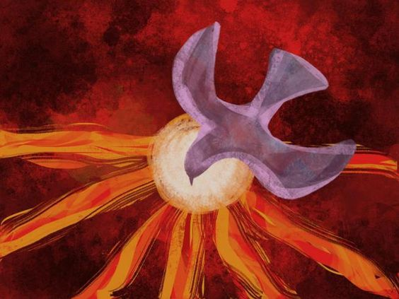
On this day of Pentecost, all of these are Spirit-Breathed gifts, ways of being the church as we continue to be the church apart, yet together in Spirit. May the Breath of Life, the Spirit of God who is as close to us as the air we breathe and yet infuses all creation, continue to inspire us, encourage us, and make all things new through us and in us. AMEN

Nadia Bolz-Weber, Shameless: A Sexual Reformation (New York: Convergent, 2019 ), 77.
Bolz-Weber, 111.
To learn more about Hildegard and see her art, you can start here: https://en.wikipedia.org/wiki/Hildegard_of_Bingen
Quoted in: Elizabeth A. Johnson, She Who Is: The Mystery of God in Feminist Theological Discourse (New York: Crossroad, 1992), 124.

