The Stones Cry Out - Palm Sunday
Co-Pastor Susanne Guenther Loewen
NPMC – April 5, 2020

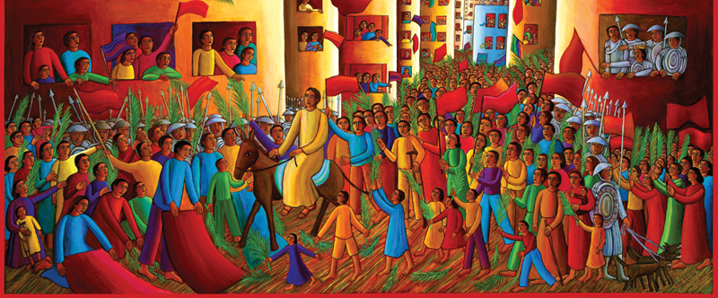

John August Swanson – Detail from “Entry into the City” (1990)

Scripture: Psalm 118:1-2, 19-29, Mark 11:1-11
Hymns: StS 73, HWB 239, StJ 98

Today is a bittersweet day. I know the children’s procession, in all its chaotic glory of little voices singing and little hands eagerly waving palm branches, is usually one of the highlights of Palm Sunday worship for me. And today we can’t gather to celebrate in that way. As I was reflecting on our Scripture for this morning, it occurred to me that both of these passages centre around crowds gathering and coming together in person, something which is not part of our current experience. We’ll have to use our imaginations these days, and our memories of crowds of people of faith, gathered together in one place – in this case, waiting for the coming Messiah to parade down the street. Today we will sing our Hosanna’s separately, but at the same time – which is still a form of togetherness.
Jan Richardson begins her poem, “The Blessing of the Palms,” this way:
This blessing
can be heard coming
from a long way off.

This blessing
is making
its steady way
up the road
toward you.

Can you picture it? The dusty, stony road, the rustling greenery of the cut branches, the restless hum of the crowd as they wait for Jesus to ride by. But what brings them there, into the streets? Perhaps rumours that this famous Jesus man they’d heard about is on his way to Jerusalem, along with all the other Jewish pilgrims preparing to celebrate the feast of Passover at the Temple. Perhaps they want to catch a glimpse of the one who has been healing and embracing the outcasts and teaching the way of good news. Perhaps they want to hear for themselves his message of liberation from fear and oppression, of love of God and neighbour, of shalom or peace with justice and equity. Slowly but steadily, on the back of the plodding donkey, Jesus makes his way to the crowds waiting outside of Jerusalem.
And as soon as he is in view, the crowd begins cheering. No one knows who started it, but the people begin shouting, “Hosanna! Hosanna!” – meaning, “Save Us, We Pray!” And then someone adds a blessing: “Blessed is the one who comes in the name of the Lord!” (Mark 11:9, NRSV). This is not a new blessing to them, but a familiar one from Psalm 118, where it continues, “Bind the festal procession with branches, up to the horns of the altar” (Ps. 118: 26, 27b). And the people begin to cut branches from the trees to wave with their Hosanna’s and to lay on the road for Jesus’ donkey to walk upon. And someone adds another blessing, one with distinctly Messianic overtones: “Blessed is the coming kingdom of our ancestor David! Hosanna in the highest heaven!” And the people lay their cloaks on the road alongside the branches, as they would for a royal procession (v. 7-10).
“The Blessing of the Palms” continues:
This blessing
blooms in the throats
of women,
springs from the hearts
of men,
tumbles out of the mouths
of children.

This blessing
is stitched into
the seams
of the cloaks
that line the road
etched into
the branches
that trace the path,
echoes in
the breathing
of the willing colt,
the click
of the donkey’s hoof
against the stones.

But wait: if this is a royal procession, it’s not very glamorous, is it? The people were used to royal processions and victory marches of the Roman Emperor and army that were much, much different than this. Those processions were shows of wealth and force, meant as much to awe as to intimidate the Jewish peasants who looked on. Those processions featured gleaming weapons and armour, war horses and chariots, platoons of marching Roman soldiers. This procession, by contrast, features an itinerant healer and preacher who doesn’t even have his own donkey! He has to borrow one to ride over the dusty cloaks and branches that line the road. Much of our passage from Mark focuses on this, that Jesus had to borrow a donkey. And Jesus’ message is not one of military might, but a vision of God’s Reign in which wars will cease and everyone will have enough.
Knowing the rest of Jesus’ story, we know he is an altogether different kind of King. But did the crowd shouting “Hosanna!” understand that? When they called him the heir of David’s kingdom, were they expecting that kind of king – a king of military might and opulent wealth? When they called him the Messiah, were they expecting Jesus to forcefully overthrow the Roman occupation? If so, they were bound to be deeply disappointed in what Jesus was about to do in his last week in Jerusalem. Yes, he publicly challenged the corruption of the Temple leaders and the cruelty of Rome. But not in the way people thought he would. All those expectations of Jesus the warrior-Messiah were about to be broken.

We know a thing or two about broken expectations these days, don’t we? As we begin Holy Week knowing we can’t gather in person as a church community, we may be feeling disappointment that Holy Week and Easter won’t look the same this year. We may be feeling loneliness for the communal worship that sustains us spiritually – especially the four-part congregational singing of those lively Easter hymns! This year, we have to let go of a lot of our expectations around what our Easter celebrations would look like – a lot of what our lives look like as a whole. And that’s not easy.
I just finished reading Unsheltered by Barbara Kingsolver, and an image in that novel stayed with me. The story is about an extended family who inherits an old, dilapidated house from an aunt, and tries to live in it as it falls apart around them. At one point, the young adult daughter and the mother get into a discussion about what it means to let go of expectations that will never materialize. “My mother used to say when God slams a door on you, he opens a window,” says the mother. “No, that’s not the same,” says the daughter, changing the metaphor to a house falling down completely. “You’re going to end up in rubble,” she says. “For sure you won’t find your way out of the mess if you keep picking up bricks and stuffing them in your pockets. What you have to do is look for blue sky.”
Have you had your moments of stuffing bricks into your pockets this week – of clinging too closely to expectations of “normal”? Have you also had moments when you’ve been able to take a deep breath and look for blue sky instead? In this time of uncertainty, we can certainly feel like we’re suddenly left without a roof over our heads. We can feel vulnerable and unsure of what to do next. We can feel afraid and worried, especially as we wonder what the timeline is on all of these health guidelines. These feelings are normal for a pandemic situation like ours. But there is a choice that we can make these days – to work on letting go of those wishes for things to be like they were (to stop stuffing those bricks into our pockets) and open ourselves to the newness of how we must live right now for the sake of our society as a whole. We can choose to treat ourselves and others with grace right now, and encourage ourselves and others to stop wishing for a roof and look for blue sky. And this applies even to our Easter worship.
As I sat with the Scripture passages for this morning, all about the joy of gathering for worship, I thought about Luke’s version of the Palm Sunday story, in which the Pharisees confront Jesus, telling him to order his disciples to be quiet. Jesus replies, “I tell you, if these were silent, the stones would shout out” (Luke 19:40). If the crowds were quiet, the stones themselves would cry out. Well, today, our church is empty and quiet. And yet Holy Week has begun and will unfold in all its cruciform grief and resurrection joy. If we ever needed a reminder that we don’t go to church, we ARE the church, this is it! Communal worship is about physically gathering as the church, but even when we are scattered, we are the church wherever we are, in whatever ways we practice and live out our faith – that doesn’t change, as this cartoon makes clear:
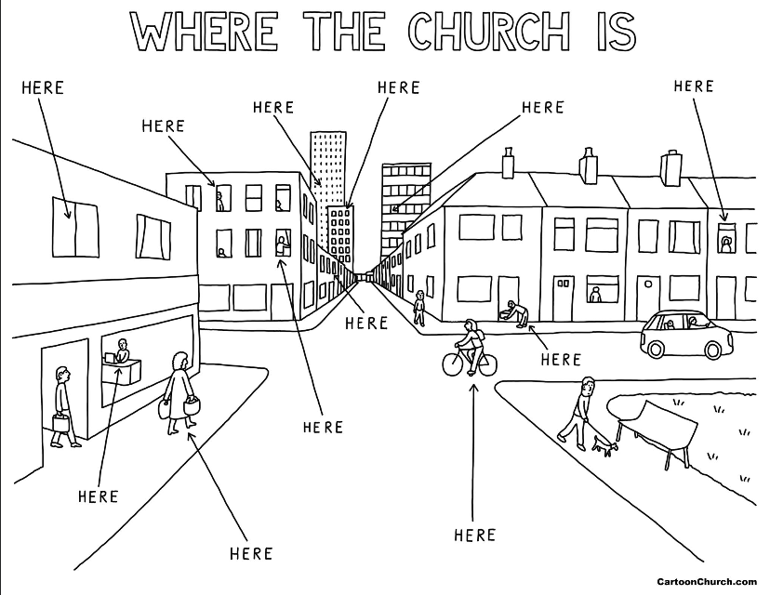
I read a reminder somewhere this week that actually, this year’s Easter will look a lot more like the biblical accounts than usual, with scattered disciples, a small group isolated in an upper room, the grief and uncertainty of what was going to happen, the few women making their way through the darkness to the ultimate upending of expectations: the empty tomb, which speaks volumes in its silence.
“The Blessing of the Palms” concludes this way:
Something is rising
beneath this blessing.
Something will try
to drown it out.

But this blessing
cannot be turned back,
cannot be made
to still its voice,
cannot cease
to sing its praise
to the One who comes
along the way
it makes.

Even though our church building sits silent and empty, the very stones are crying out their praises. Even scattered, we are the church, connected through our shared faith in God, who holds us in the palms of God’s hands. Even as we travel this unfamiliar road this Holy Week, let us remember to bless the One who is our constant companion on the way. Hosanna! AMEN

Benediction:
Blessed is the One
who comes to us
by the way of love
poured out with abandon.

Blessed is the One
who walks toward us
by the way of grace
that holds us fast.

Blessed is the One
who calls us to follow
in the way of blessing,
in the path of joy.
AMEN

http://diglib.library.vanderbilt.edu/act-imagelink.pl?RC=56544
Jan Richardson, “The Blessing of the Palms: For Palm Sunday,” in Circle of Grace: A Book of Blessings for the Seasons (Orlando, FL: Wanton Gospeller Press, 2015), 123-4.
Jan Richardson, 123-4.
Barbara Kingsolver, Unsheltered (New York: Harper Collins, 2018), 415.
Jan Richardson, 124.
Jan Richardson, “Blessed Is the One: For Palm Sunday,” Circle of Grace, 125.

